**QM Lab 2 - Quantum Espresso**

1. Total energy as a function of cutoff energy, which ranged from 10 to 140 Ryd by increments of 10 Ryd. The convergence value was calculated to be 110 Ryd. This means the change from 100 to 110 Ryd is less than 5 meV/atom. As cutoff energy increases towards infinity the total energy approaches some value asymptotically (about -22.79157949). The calculations with a primitive cell are more efficient than using the cubic cell, whereas calculations using the cubic cell could give more information.

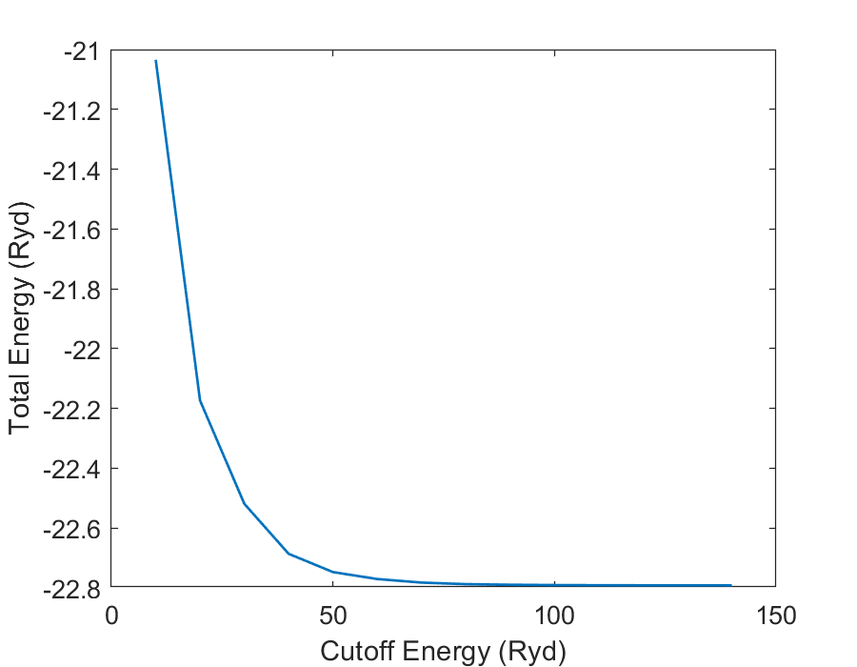

1. Total energy as a function of k-point grid size. The k values ranged from 1 to 8 by increments of 1, resulting in the grid sizes 1, 3, 4, 8, 10, 16, 20, and 29 respectively. Convergence was calculated to occur at a grid size of 20 using the same method as the previous problem. This results in the same trend as problem 1, converging towards an energy value as grid size increases.

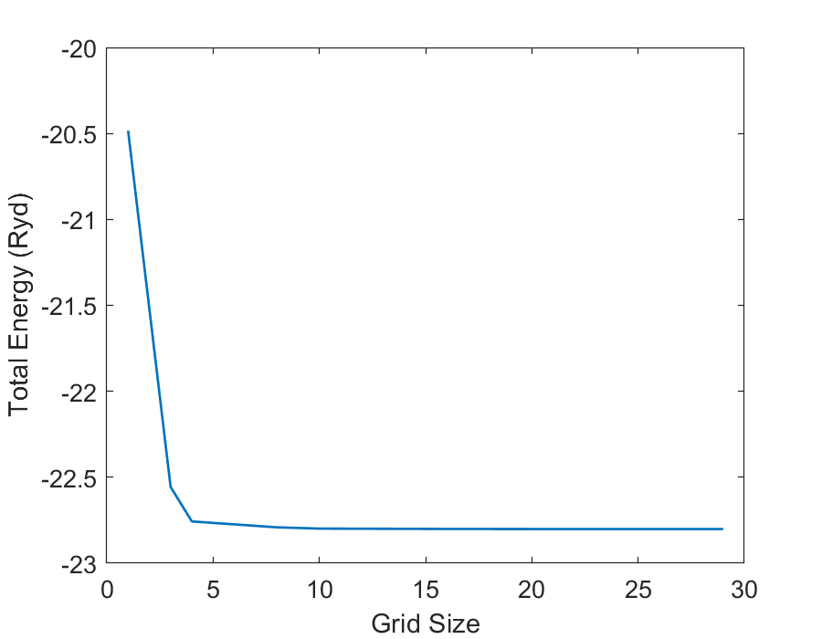

1. A C atom was displaced by +0.05 in the z direction resulting in the plotted force on atom 1 as a function of the cutoff energy. The force on atom 2 is equal in magnitude but the opposite sign, for this reason only atom 1 is plotted. Convergence was calculated with the condition that a change in force of less than 10 meV/Angstrom signifies convergence. The cutoff energy value for convergence is 100 Ryd.

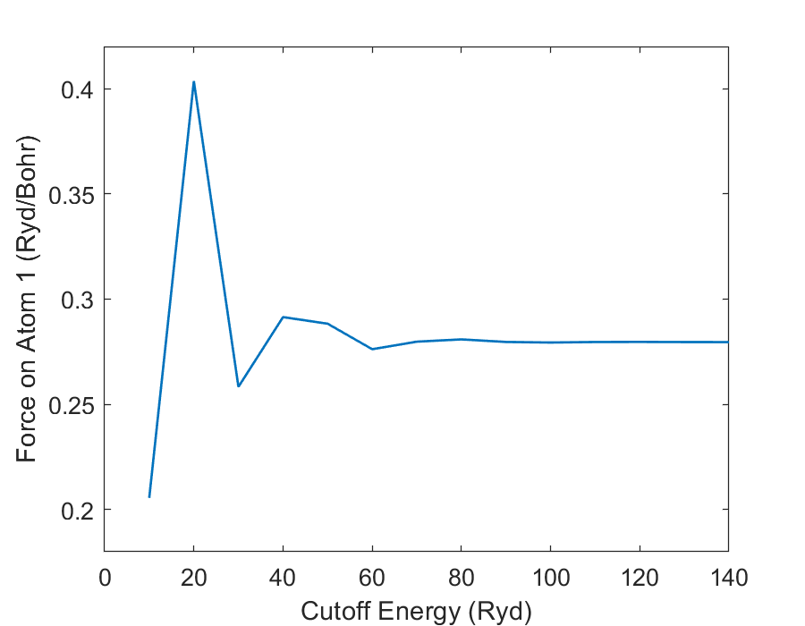

1. Total energies for both the lattice parameters of 6.74 and 6.70 Bohr were calculated with cutoff energies ranging from 10 to 140 Ryd by increments of 10 Ryd. Plotted below is the difference between these total energies for each lattice parameter versus the respective cutoff energy. The condition for convergence is a change less than 5 meV/atom. This first occurs at a cutoff energy of 30 Ryd, but larger changes occur at 40 and 50 Ryd. Thus the total energy is converged at a cutoff energy value of 60 because all subsequent changes are less than 5 meV/atom.

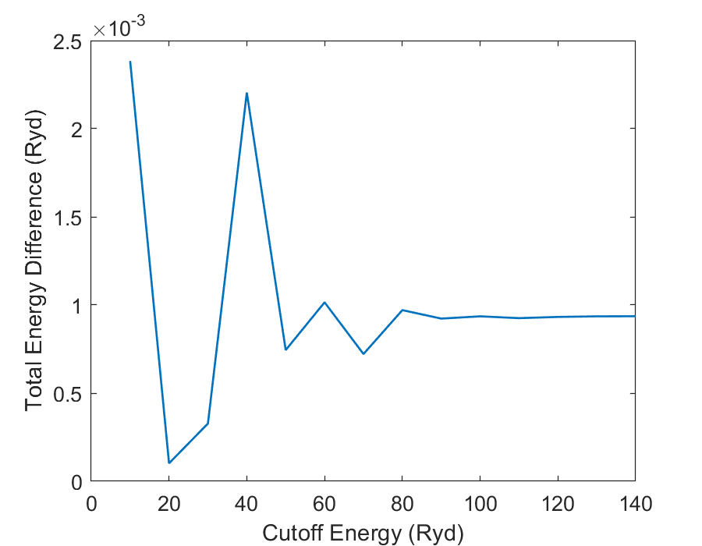

5. The 3 convergence values when looking at absolute energies, forces, and energy difference are 110 , 100, and 60 Ryd respectively. For problems 1 through 4 the number of k points at the converged values were 8, 20, 18, and 8 respectively. The converged cutoff energy values result in a higher amount of k points than lower cutoff energies. To ensure accurate QM calculations one would need to make sure each value converges individually and then use those values in that range for subsequent calculations. Use a sufficiently large number of k-points and a converged cutoff energy value.

6. Equilibrium lattice of constant of diamond was found to be 6.66 Bohr by PWSCF calculation. The total energy for multiple lattice parameters was calculated and the one that resulted in the least total energy is the equilibrium lattice constant.

7. e

8. e

9. e